SliceWise — Design Package
FOR EXAMPLE PURPOSES ONLY. This design package is for a sample research and development project (SliceWise). Each team should review and assess every section for applicability, rewrite it for its own system and research questions, and consider items this example does not include. Examples of items you may need: a literature review with the papers your method builds on; a pre-registration of hypotheses; a power analysis for your study size; the exact IRB-approved consent text; a model card for any model you train or fine-tune; security review of the IDE extension; and a data management plan required by your university.
SliceWise turns a Java code change into a ranked list of impacted code regions and an explanation of how the change reaches each one. A static slicing engine does the reasoning; a language model only writes the explanation, and a grounding check rejects any sentence that is not backed by a real dependence in the slice. Everything is evaluated twice: against ground truth on a benchmark of real changes (RQ1, RQ2) and with developers in a controlled study (RQ2, RQ3).

1. Technology choices
Concern | Choice | Why | Alternatives considered
Program analysis | WALA (call graph, system dependence graph, full and thin slicers) | Mature Java bytecode analysis with a built-in context-sensitive slicer and thin slicing | SootUp (modern, but slicing must be built), Joana (strong SDGs, less maintained), CodeQL (licensing limits)
Source mapping and diff parsing | JavaParser + JGit | Map bytecode statements back to source lines; read diffs between commits | Eclipse JDT (heavier)
Engine service | Java 21, Javalin REST, Gradle | Same language as WALA; small, fast HTTP layer | Spring Boot (more than needed)
Explanation service | Python 3.12, FastAPI | Prompting, grounding check and evaluation code share one language | Node.js
Language model | Open-weight code model [to be chosen, I-01] served by vLLM on the department GPU server | Code and study data stay on campus; fixed model version for reproducibility | Hosted APIs (not allowed for study data, C-02)
IDE tool | VS Code extension in TypeScript | Most-used editor among participants; decorations and webview panels fit the UI | IntelliJ plugin (stronger Java support, steeper learning curve)
Benchmark and ground truth | Python (pandas), JaCoCo + a small Java agent for per-test traces, Maven/Gradle in Docker | Reproducible builds of subject projects at pinned JDK versions | Hand annotation only (too slow, less objective)
Experiment tracking | MLflow | Every run logged with commit, data version, model and prompt version | Spreadsheets (error-prone)
Storage | MariaDB (results, study data under study IDs); file store for SDG caches | Department standard | PostgreSQL
Statistics | Python (scipy, statsmodels), R optional for mixed models | Paired tests and mixed-effects models for the study | —
Deployment and CI | Docker Compose on a department OpenStack VM; self-hosted GitLab CI | Department standard; one command to redeploy | —

2. How SliceWise works
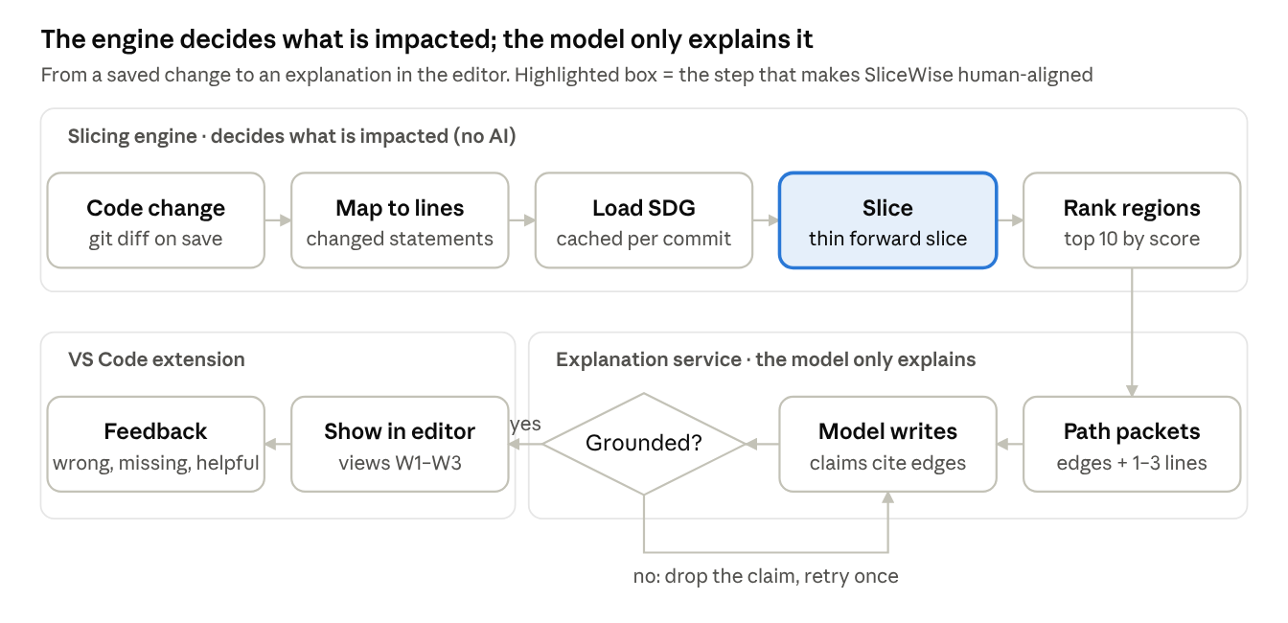
pipeline · change to explanation, 9 steps, 1 check

Everything above the line is deterministic program analysis, so the impact list is the same every time for the same change. The model sees only the paths the engine found; if it writes a claim it cannot back with a cited edge, the claim is dropped. After a second failure the editor shows the bare dependence path instead of prose.

3. Problem formulation
A program version is represented as a system dependence graph (SDG): nodes are statements, edges are data dependences (a value written here is read there), control dependences (this statement decides whether that one runs), and call/parameter edges between methods.
$$G=\left(V,E\right), E=E_{data }∪ E_{ctrl} ∪ E_{call}∪E_{param}$$

The diff between the base and changed version gives the set of changed statements C ⊆ V. The forward slice is every statement reachable from a changed statement along dependence edges (computed context-sensitively, so calls return to the right caller):
$$FS\left(C\right)=\left( v ∈V \right| ∃c ∈C :c → *_{E}v$$
A thin forward slice follows only "producer" data edges — where a value actually flows — and leaves out control dependences and pointer-base uses. Thin slices are smaller and are reported to match what developers inspect, which makes them the main candidate for human-aligned results (EXP-02):
$$TS\left(C\right)=\left\{ v∈V∣∃ c∈C:c→_{E_{thin}}^{*}v \right\}, E_{thin}⊆E_{data}$$

The impact set at method level is the set of methods containing a sliced statement, excluding the changed methods themselves; statement-level results are kept for highlighting.
$$I_{m)=\left\{ method\left(v\right)∣v∈S\left(C\right) \right\}∖method\left(C\right), S∈\left\{FS,TS\right\}}(C$$

Each impacted region r is ranked by a weighted score of dependence features: shortest dependence distance d(r), number of distinct paths p(r), share of data (vs control) edges on those paths, whether a path crosses a public API, and whether r is test code. Weights are tuned on the development split only (EXP-04).
$$score\left(r\right)=w_{1}\frac{1}{1+d\left(r\right)}+w_{2}\log\left(1+p\left(r\right)\right)+w_{3} data\left(r\right)+w_{4} api\left(r\right)-w_{5} test\left(r\right)$$

An explanation is a list of claims. A claim is grounded when it cites at least one slice edge and every code element it names (method, field, variable) appears on its cited edges.

4. Research design
Research question | Method | Data | Main measures
RQ1 Accuracy | Compare SliceWise variants with four baselines on the same changes | Benchmark dev split (tuning), locked test split (once, week 18) | Method-level precision, recall, F1; precision@10; MRR
RQ2 Alignment | (a) Automatic faithfulness check of every explanation; (b) compare explanation paths with annotators' written reasons; (c) participant ratings in the study | Locked test split; human-annotated subset; study ratings | Grounded-claim rate; invented-element rate; reason overlap; Likert ratings of correctness, completeness, usefulness
RQ3 Developer outcome | Within-subjects controlled study, SliceWise vs a token-level AI assistant | [≥ 20] participants × 4 tasks | Task accuracy (F1 of impacts found + correct edit), time on task, NASA-TLX workload, SUS
Baselines and variants
ID | Name | What it does
B0 | Diff only | Reports only the changed methods (lower bound)
B1 | Call-graph reachability | All methods that transitively call or are called by the changed methods (classic CIA)
B2 | Token-level LLM | Same model as SliceWise; gets the diff plus the changed files and their callers as text (same token budget) and lists impacted methods with reasons
B3 | Embedding retrieval + LLM | Retrieves code chunks most similar to the diff, then asks the model as in B2
SW-F | Full forward slice | SDG forward slice, ranked, no LLM
SW-T | Thin forward slice | Thin slice, ranked, no LLM
SW-TX | SliceWise | Thin slice + ranking + grounded explanation (the tool)
Benchmark and ground truth
- Subject projects: [6–8] open-source Java projects of 10–100 KLOC with good test suites, e.g., from Defects4J plus recently active projects; licenses checked (C-07).
- Changes: [~200] real commits that change 1–3 methods' behavior (bug fixes and small features; no pure refactorings or formatting). [~140] go to the development split and [~60] to the locked test split, with ≥ [30] locked changes committed after the model's training cutoff (contamination check, EXP-07).
- Dynamic ground truth (all changes): run the test suite on both versions with a tracing agent; a method is impacted if, for at least one test, its observed inputs, outputs or field writes differ between versions. This gives an objective but incomplete lower bound (only tested behavior).
- Human ground truth ([60] changes): two annotators independently list impacted methods and write one sentence on why; a third adjudicates; Cohen's kappa ≥ 0.7 is required before the labels are used. The written reasons are the reference for RQ2(b).
- Results are reported against each ground truth separately and against their union.

5. Evaluation metrics and statistical analysis
For each change, with predicted impact set P and ground-truth set T (both at method level):
$$Precision=\frac{\left|P∩T\right|}{\left|P\right|}, Recall=\frac{\left|P∩T\right|}{\left|T\right|}, F_{1}=\frac{2⋅Precision⋅Recall}{Precision+Recall}$$
Ranked outputs are also scored with precision@10 and mean reciprocal rank (the rank of the first truly impacted method). Metrics are averaged per change (macro), so large changes do not dominate.
Analysis | Test | Why
RQ1: SliceWise vs each baseline | Paired Wilcoxon signed-rank on per-change F1; Holm correction for multiple baselines; effect size (Cliff's delta); bootstrap 95% CI of the F1 difference | Per-change F1 is not normally distributed; same changes in every condition
RQ1: per Java feature | F1 broken down by changes touching lambdas/streams, inheritance, reflection, static fields | Shows where slicing is unsound (R-03)
RQ2(a) faithfulness | Rates with 95% Wilson CI | Proportions
RQ2(b) reason overlap | Share of annotators' reasons matched by an explanation path (two raters, kappa reported) | Measures alignment with human reasoning
RQ3 accuracy and time | Linear mixed-effects model: outcome ~ condition + task order + (1 | participant) + (1 | task); time log-transformed | Within-subjects design with task and order effects
RQ3 workload, usability | Wilcoxon signed-rank (NASA-TLX); SUS reported with mean and CI | Ordinal or bounded scales
A power check from the pilot (variance of time and accuracy) confirms whether n = [20] can detect the target effect; if not, the report states the study as exploratory.

6. User study design
The study is within-subjects: every participant does two tasks with each condition, so each person is their own comparison. Condition order and task assignment are counterbalanced (Latin square) to cancel learning effects.
Element | Design
Participants | [≥ 20] developers with ≥ 1 year of Java: upper-level SE students and alumni volunteers; no participant is graded by a team member's instructor for this course (C-08)
Condition A — baseline | VS Code + a chat assistant using the same language model, given the diff and open files (token-level, like B2)
Condition B — SliceWise | VS Code + SliceWise (highlights, impact panel, propagation view, explanations)
Tasks | 4 maintenance tasks on one unfamiliar subject project not used for tuning: a teammate's change is shown; the participant (1) lists the code it affects and (2) makes a follow-up edit so the tests pass. Tasks come in 2 matched pairs of similar difficulty
Time cap | 12 minutes per task
Measures | Task accuracy (F1 of listed impacts vs ground truth; edit passes hidden tests yes/no); time on task; NASA-TLX after each condition; SUS and trust items after condition B; ratings of 5 explanations (correct, complete, useful, 1–5); think-aloud on one task per condition
Logged by the tool | Panel opens, clicks on impacted regions, explanation views (study ID only, with consent)
Length | About 60 minutes
Session flow
- Consent and background questionnaire (5 min)
- Tool tutorial on a toy project for both conditions (10 min)
- Condition 1: two tasks, then NASA-TLX (25 min)
- Condition 2: two tasks, then NASA-TLX and SUS (25 min, overlapping with breaks)
- Explanation ratings and short interview (5 min)
The pilot (week 18, [3–4] people) checks task difficulty, timing and tool stability; changes after the pilot are filed as an IRB amendment before week 20.

7. Explanation generation and grounding
The model never decides what is impacted; it only explains paths the engine already found. For each impacted region (top 10 by rank), the explanation service sends a compact path packet: the changed lines, then each dependence path to the region as numbered edges, each edge with its kind (data, control, call, return) and the 1–3 source lines at both ends. The prompt asks for 2–4 short claims in developer language ("the new return value of parseRate is stored in rate, which decides whether applyDiscount runs") and requires each claim to list the edge IDs it relies on.
{
"region": "OrderService.applyDiscount",
"claims": [
{"text": "parseRate now returns 0 for blank input instead of throwing.", "edges": ["e1"]},
{"text": "That value is stored in rate, which controls whether applyDiscount runs.", "edges": ["e2", "e3"]}
]
}
Grounding check (runs on every response):
- Parse the JSON; reject if any claim has no edge IDs or cites an edge not in the packet.
- Extract identifiers from each claim and check they appear on the cited edges' source lines.
- Drop failing claims and regenerate once; if it still fails, show the dependence path without prose and log the failure.
- Log grounded-claim and invented-element rates to MLflow per run (RQ2a).
Model settings are fixed for reproducibility: temperature 0, fixed seed, pinned model and prompt versions.
Data sent to the language model
Sent | Not sent
Changed lines and the 1–3 lines at each end of slice edges (code from the project being analyzed) | Participant names, emails, study IDs or think-aloud transcripts
Method, class and field names on those paths | Whole files or repositories (except in baseline B2/B3, which by design get file text)
Edge kinds and IDs | Anything outside university systems: the model runs on the department GPU server (C-02)

8. System architecture
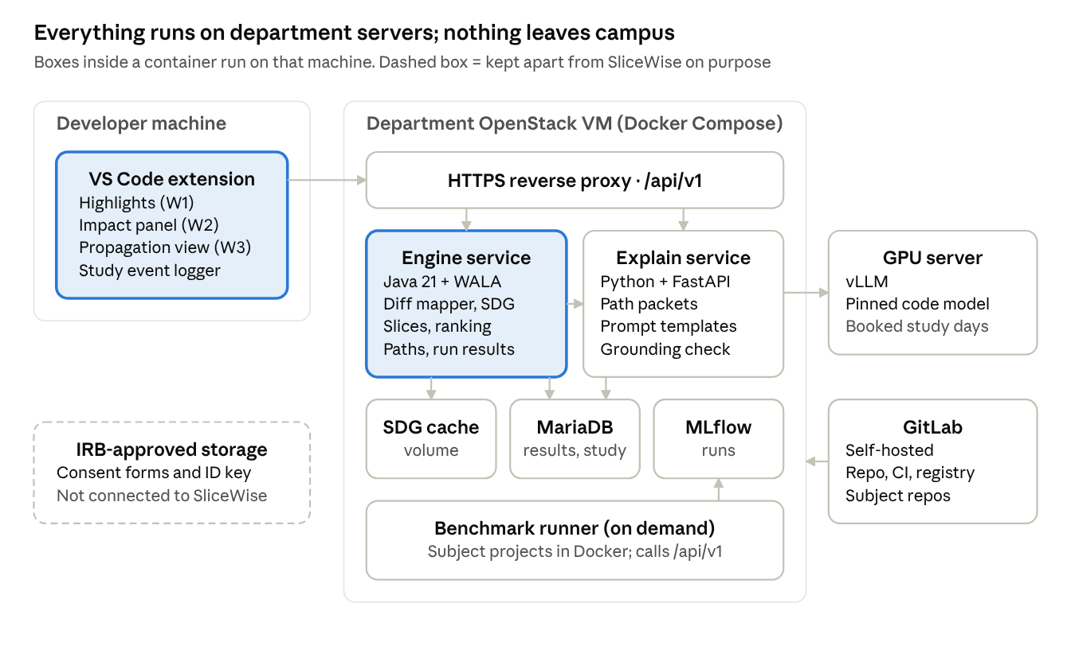
architecture · developer machine, VM, GPU server, GitLab
The extension talks only to the proxy. The engine owns all program analysis and stores every run; the explain service calls the model on the GPU server and records each claim with its grounding result. GitLab CI builds images and deploys tagged releases to the VM. Consent forms and the name-to-ID key never touch any SliceWise component.

9. Sequence: impact and explanation
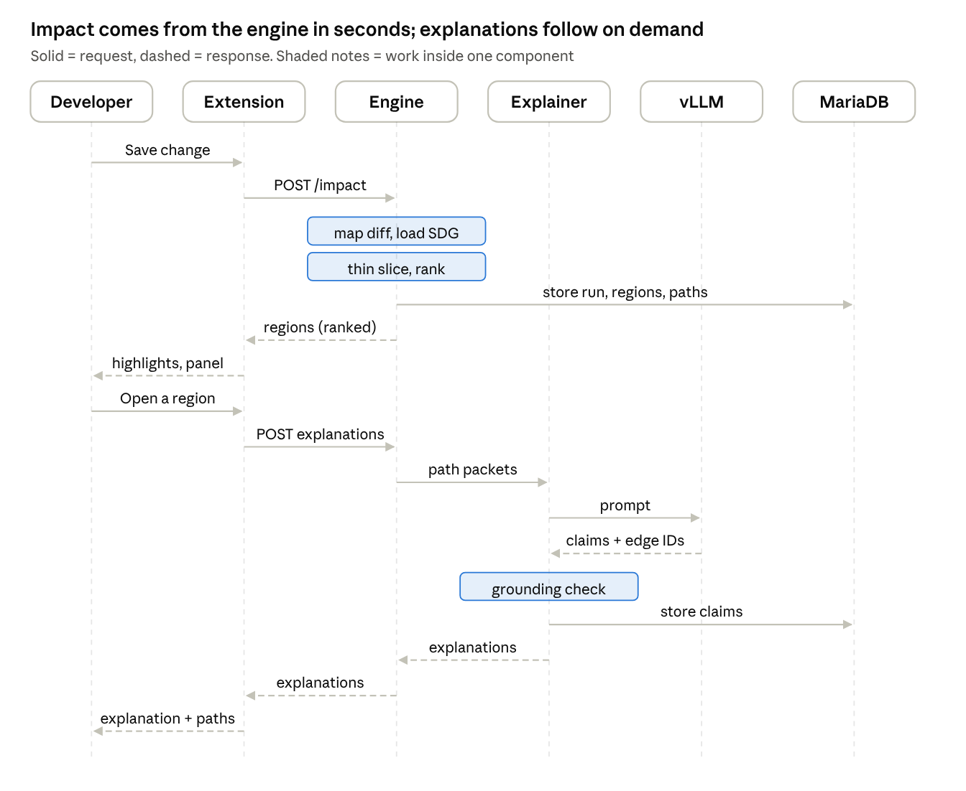
sequence · impact request, then explanation on demand
Impact results come back without waiting for the model, so highlights appear within the 10-second target. Explanations are generated only when the developer opens a region, and are cached by change, region and prompt version.

10. API endpoints
Base path /api/v1, JSON over HTTPS on the department network. The VS Code extension and the benchmark runner use the same API. Requests carry a service token (CI variable) or, in the study, a session token tied to a study ID.
Method | Path | Purpose | Notes
POST | /projects | Register a project (git URL or uploaded workspace) and build settings | Returns projectId
POST | /projects/{id}/builds | Build call graph and SDG for a commit | Async job; returns buildId
GET | /projects/{id}/builds/{buildId} | Build status, time, node and edge counts | Polled by the extension
POST | /impact | Compute impact for a change: projectId, baseCommit, diff or headCommit, mode (full | thin), granularity (statement | method) | Returns impactId; result in ≤ 10 s p95 when the SDG is cached
GET | /impact/{id} | Ranked impacted regions with file, line range, score, distance | Drives W1 highlights and W2 list
GET | /impact/{id}/paths?region={regionId} | Dependence paths from changed lines to one region (edge list with kinds and lines) | Drives W3 propagation view
POST | /impact/{id}/explanations | Generate grounded explanations for the top regions (or one region) | Proxied to the explanation service; cached per prompt version
GET | /impact/{id}/explanations | Stored explanations with claims, cited edges and grounding status
POST | /feedback | Developer marks a region or claim as wrong, missing or helpful | Feeds error analysis
POST | /study/events | Batched interaction events (study ID, task ID, event type, time) | Enabled only in study mode, after consent
POST | /bench/runs | Start a benchmark run (split, variant, model and prompt version) | Team only; logs to MLflow
GET | /health | Liveness and versions of engine, model and prompt | Used by CI smoke test
Errors use RFC 7807 problem JSON. Breaking changes go to /api/v2; the study runs against a frozen API version.

11. Data model
One MariaDB schema holds analysis results, explanations, evaluation scores and study data. Study tables use study IDs only; the name-to-ID key lives in the IRB-approved store, not here. SDGs themselves are cached as files, referenced by path.
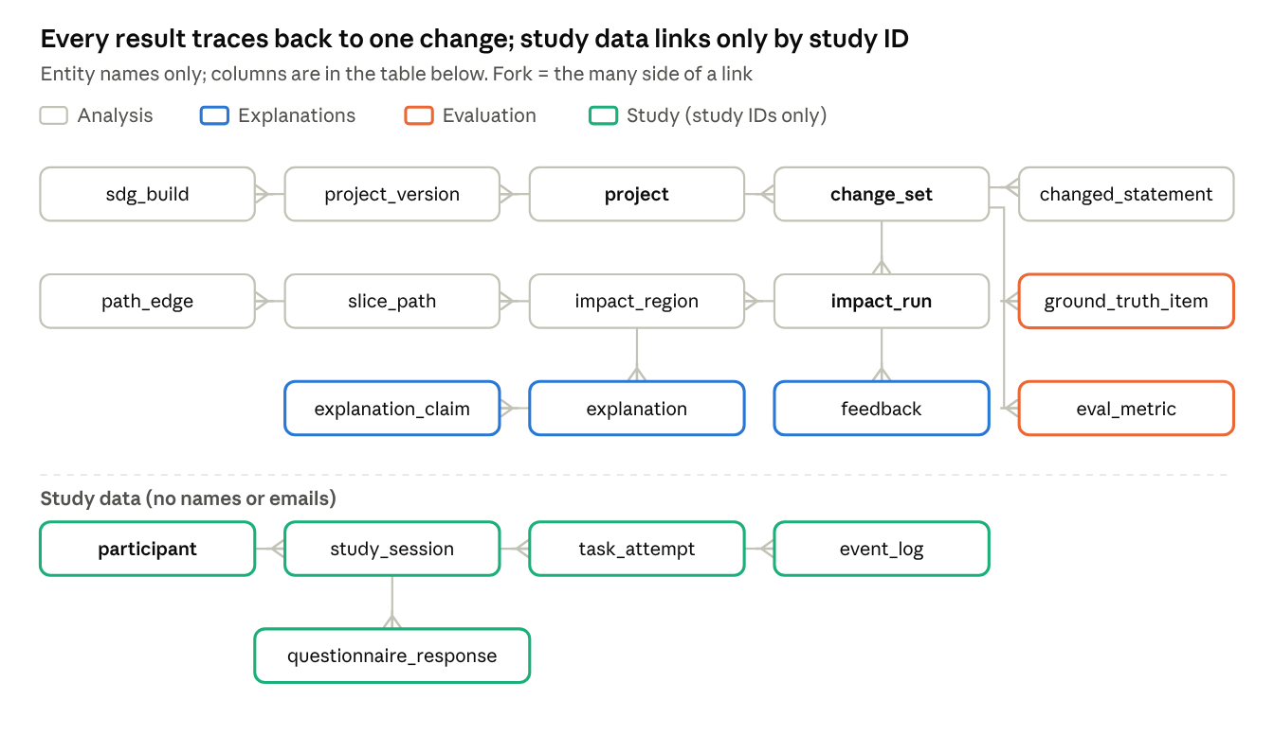
ERD · 19 tables in four groups
One more link is not drawn to keep the picture readable: task_attempt.change_id points to the change_set a study task is based on.
Table | Key columns | Notes
project | project_id PK, name, repo_url, license, kloc, jdk_version | Subject project or a participant's workspace
project_version | version_id PK, project_id FK, commit_sha | One row per analyzed commit
sdg_build | build_id PK, version_id FK, mode, nodes, edges, build_seconds, heap_mb, cache_path, status | Build cost data for R-02 and success criterion 3
change_set | change_id PK, project_id FK, base_version_id FK, head_version_id FK, split (dev | test | study | ide), commit_date, post_cutoff | Benchmark changes and live IDE changes
changed_statement | id PK, change_id FK, file, line, node_ref | Output of the diff mapper
impact_run | impact_id PK, change_id FK, variant (B0–B3, SW-F, SW-T, SW-TX), mode, granularity, engine_version, runtime_ms | One run of one variant on one change
impact_region | region_id PK, impact_id FK, method_sig, file, line_start, line_end, score, rank, distance | Ranked results
slice_path / path_edge | path_id PK, region_id FK / edge_id PK, path_id FK, seq, kind (data, control, call, return, param), src_file, src_line, dst_file, dst_line | Ordered paths from changed lines to a region; explanation claims cite edge_id
explanation | expl_id PK, region_id FK, model_name, prompt_version, grounded, regenerated | One per region per prompt version
explanation_claim | claim_id PK, expl_id FK, text, cited_edges (JSON), grounded, invented_elements | Unit of the RQ2(a) faithfulness rate
feedback | fb_id PK, impact_id FK, region_id FK, claim_id FK, kind (wrong | missing | helpful), comment | From developers and the study
ground_truth_item | gt_id PK, change_id FK, method_sig, source (dynamic | human), annotator_code, reason | Annotator codes, not names
eval_metric | metric_id PK, mlflow_run_id, change_id FK, variant, precision, recall, f1, p_at_10, rr | Per-change scores; aggregated in reports
participant | study_id PK, java_years, group (student | alumni), condition_order | No names or emails
study_session | session_id PK, study_id FK, session_date, pilot
task_attempt | attempt_id PK, session_id FK, task_code, condition (A | B), change_id FK, seconds, impacts_listed (JSON), f1, tests_pass | RQ3 outcomes
event_log | event_id PK, attempt_id FK, ts, type, target | Tool interactions, study mode only
questionnaire_response | resp_id PK, session_id FK, instrument (TLX | SUS | trust | rating), item, value

12. Test plan
Research software is tested like product software, plus checks that the science is right.
Level | What is tested | How | When | Pass rule
Unit | Diff mapper, slice options, ranking score, grounding parser | JUnit (engine), pytest (services) | Every merge request | All pass; coverage ≥ [70%]
Oracle tests for slicing | Engine slices on [20] small programs with hand-computed slices (loops, fields, calls, lambdas, exceptions) | Golden files reviewed by two members | Every merge request | Exact match, or a documented known gap
Integration | Engine ↔ explanation service ↔ MariaDB; extension ↔ API | Docker Compose test stack with a 2 KLOC sample project | Nightly in CI | End-to-end impact + explanation in < 30 s
Contract | API responses match the OpenAPI spec | Schemathesis against the running stack | Every merge request touching the API | No schema violations
Benchmark regression | F1 and runtime on a fixed 20-change smoke set | Benchmark runner, compared to the last tagged release | Nightly | F1 not lower by > 0.02; runtime not > 20% slower
Explanation quality | Grounded-claim and invented-element rates; manual audit of 50 explanations | Grounding check + two reviewers | Each release | Meets charter criterion 2
Usability | Study tasks run end to end with the tool | Team dry run (wk 17), pilot (wk 18) | Before main study | No task blocked by a tool error
Reproducibility | Replication package rebuilds RQ1 tables | A member who did not write it runs one command | R2 and R3 | Same numbers to 3 decimals
Security and privacy | Secrets, logging of study data, network exposure | Checklist review; dependency scan in CI | Each release | No secrets in repo; study mode logs only study IDs

13. Deployment and operations
- Department OpenStack VM ([8 vCPU, 64 GB RAM] — slicing is memory-hungry): Docker Compose runs the engine, explanation gateway, MariaDB, MLflow and a reverse proxy with HTTPS. SDG caches live on an attached volume.
- Department GPU server: vLLM serves the pinned model version; the explanation gateway calls it over the department network. GPU time is booked for benchmark runs and study weeks (C-05).
- Benchmark runner: Docker images per subject project pin the JDK and build tool; nightly smoke runs in GitLab CI, full runs on demand.
- VS Code extension: packaged as a .vsix from CI; installed on lab machines for the study; points to the VM by a setting.
- Pipeline (self-hosted GitLab CI): build → unit and oracle tests → contract tests → integration stack → benchmark smoke set → deploy to the VM on tags.
- Monitoring: /health checked every 5 minutes during study weeks; logs kept 30 days; a study-day checklist (GPU up, cache warm for study tasks, backup of study tables after each session).
- Freeze points: engine tagged for the locked test run (week 18); API, model and prompt versions frozen for the main study (week 19).
- Handoff: runbook, architecture notes, replication package and an archived copy of the VM configuration in the repository.

14. Ethics, privacy, responsible AI and threats to validity
- Human subjects: IRB approval before any session; informed consent; voluntary, ungraded participation; withdraw any time with data deleted on request; study IDs only in analysis data.
- Honest tool claims: participants are told SliceWise is a research prototype and its explanations can be wrong.
- Faithful AI output: the model explains only engine-found paths; ungrounded claims are dropped and logged, not hidden.
- Fair comparison: the baseline assistant uses the same model and effort; we report where SliceWise loses.
- Licenses: subject code is used under its license; the public replication package contains only metadata and short excerpts the license allows.
Threat to validity | Type | How we reduce it
Test-based ground truth misses untested behavior | Construct | Add human ground truth; report test coverage per change
Annotators share our view of "impact" | Construct | Written guidelines before annotation; kappa; adjudication by a third person
Model saw benchmark projects in training | Internal | Post-cutoff changes in the locked split; EXP-07 compares before and after
Tuning on test data | Internal | Locked split scored once with the frozen engine
Learning and fatigue in the study | Internal | Counterbalancing; matched task pairs; time caps; breaks
Students are not professional developers | External | Include alumni; report experience; avoid claims about industry teams
Few projects, one language | External | State limits; choose projects from different domains
Static analysis gaps (reflection, frameworks) | Conclusion | Per-feature results; list unsupported features in the tool's UI

